Brandon Rumbarger
Advanced Machine Learning
November 6, 2026
Time-Series Weather Forecasting
The climate dataset was used to build recurrent neural network models that forecast future temperature from historical weather observations. The experiments compared a SimpleRNN, an LSTM, a GRU, stacked GRU layers with different unit counts, and a model combining a one dimensional neural network with a GRU. MAE was used to compare forecasting performance. Validation MAE was used to select models, while test MAE measured performance on data held out from model development.
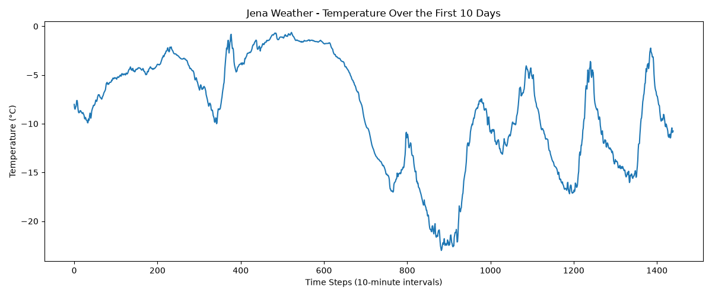
The dataset contains weather observations recorded at ten minute intervals. This assignment focused on the temperature variable. The graph shows the temperature pattern across the first ten days at the original ten-minute sampling frequency. The series includes gradual changes and more abrupt fluctuations. Every sixth observation was selected to produce an hourly temperature series.

The hourly series was divided chronologically into training, validation, and test segments, using 50%, 25%, and 25% of the observations. The model input consisted of the previous 120 hourly observations, representing five days of temperature history. The target was the temperature 24 hours after the end of the input sequence. This setup allowed the models to learn temporal patterns from recent weather history and predict a future temperature value.
The temperature data was normalized before model training. The first experiments compared SimpleRNN, LSTM, and GRU layers. Each model was trained for ten epochs. Training MAE generally decreased during the epochs, while validation MAE remained comparatively stable. The LSTM and GRU validation curves were close to one another, and the SimpleRNN showed a slightly higher validation error.
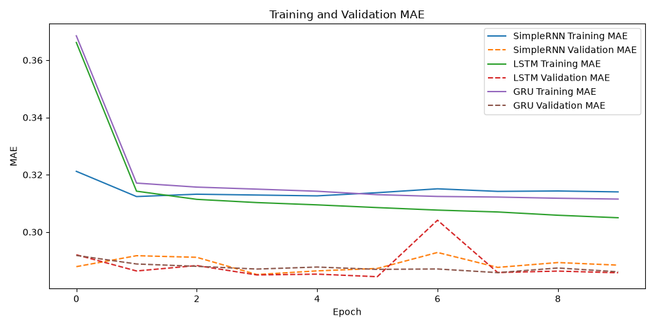
The LSTM achieved the lowest validation MAE among the three single layer recurrent models, at approximately 0.2858. The GRU was close at approximately 0.2861, while the SimpleRNN recorded approximately 0.2884. The small differences indicate that the three recurrent approaches performed similarly in this initial comparison.
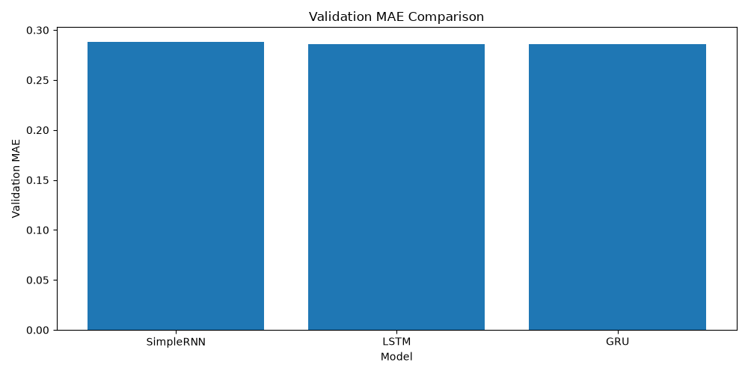
Additional experiments examined stacked GRU layers with different unit counts: 32 and 16 units, 64 and 32 units, and 32 and 32 units. These configurations tested whether changing recurrent depth and capacity could improve forecasting. A further architecture combined a one-dimensional convolutional layer with a GRU. The convolutional layer used 32 filters and a kernel size of five, followed by a GRU with 16 units and a dense output layer.
Across the architecture experiments, the CNN and GRU achieved the lowest validation MAE, approximately 0.2818. The stacked GRU with 64 and 32 units achieved approximately 0.2831, which was the strongest of the stacked GRU configurations. The CNN and GRU's lower validation error suggests that extracting local sequence patterns with a convolutional layer before recurrent processing was useful in this experiment.

Model | Validation MAE | Test MAE
SimpleRNN | 0.2884 | 0.3084
LSTM | 0.2858 | 0.3033
GRU | 0.2861 | 0.3068
Stacked GRU (32, 16) | 0.2848
Stacked GRU (64, 32) | 0.2831
Stacked GRU (32, 32) | 0.2847
CNN and GRU | 0.2818 | 0.3039

The CNN and GRU was selected based on validation MAE, in accordance with the model-selection approach for the assignment. Its reported test MAE was 0.3039. The LSTM's previously reported test MAE was 0.3033, which is marginally lower, but test performance was not used to select the model. The difference between these test values is small, and model selection should remain based on validation results.
Each model configuration was trained using a limited set of settings and a single run, so results may vary with random initialization. In addition, the reported MAE values are in normalized temperature units rather than Celsius.

